LIGHT AGRIBUSINESS
ACADEMY
Certification Pathway & Professional Short Courses
Building the Knowledge, Skills and Professionals to Transform Agriculture.
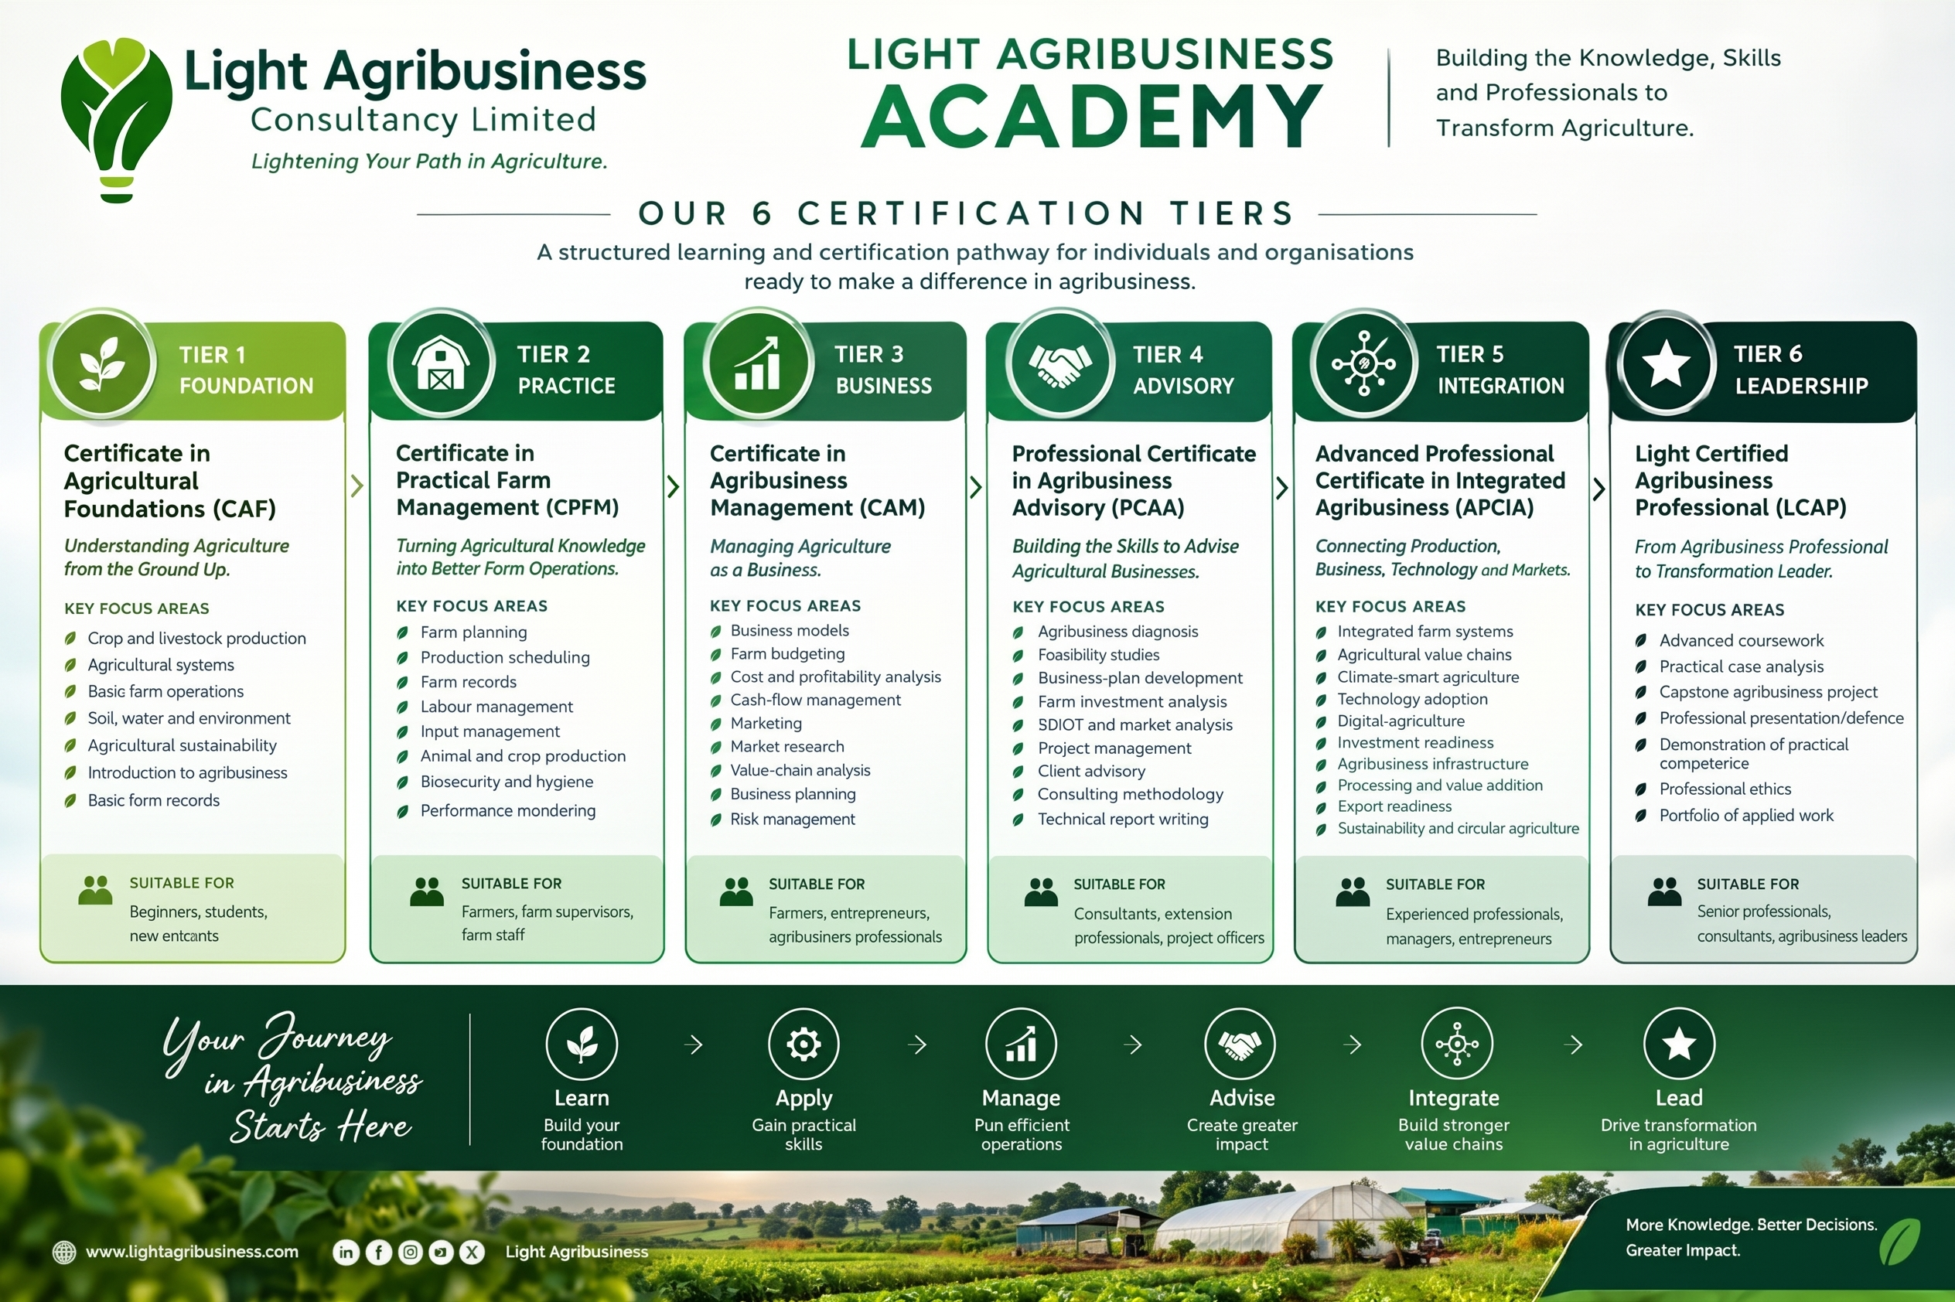

ACADEMY PROGRAMME CATALOGUE | 2026

1. Academy Overview
Light Agribusiness Academy is the knowledge and capacity development platform of Light Agribusiness Consultancy Limited, designed to equip individuals, enterprises and organisations with practical knowledge that can be applied across the agricultural and agribusiness ecosystem.
The Academy combines structured professional certification with flexible, independent short courses. The certification pathway supports progressive professional development, while the short-course portfolio allows learners to select targeted skills without following a fixed sequence.
Academy Learning Philosophy
Learn what you need. Apply it in real agribusiness. Build competence. Create measurable value.

2. Programme Architecture
The Academy has two complementary learning routes:
Route | Purpose | Structure
Six-Tier Certification Pathway | Progressive professional development and recognition of competence. | Tier 1 → Tier 6
Independent Short Courses | Targeted, practical skills for different sectors, stages and enterprise needs. | 12 courses; no fixed order

3. Six-Tier Professional Certification Pathway
The six tiers are designed as a structured pathway from foundational agricultural understanding to advanced agribusiness leadership. Learners can progress through the tiers according to programme requirements and demonstrated competence.

Tier 1 — Foundation
Certificate in Agricultural Foundations (CAF) | Understanding Agriculture from the Ground Up.
Key focus areas:
- Crop and livestock production
- Agricultural systems
- Basic farm operations
- Soil, water and environmental concepts
- Agricultural sustainability
- Introduction to agribusiness
- Basic farm records
Suitable for: Beginners, students and new entrants

Tier 2 — Practice
Certificate in Practical Farm Management (CPFM) | Turning Agricultural Knowledge into Better Farm Operations.
Key focus areas:
- Farm planning
- Production scheduling
- Farm records
- Labour management
- Input management
- Animal and crop production management
- Biosecurity and hygiene
- Performance monitoring
Suitable for: Farmers, farm supervisors and farm staff

Tier 3 — Business
Certificate in Agribusiness Management (CAM) | Managing Agriculture as a Business.
Key focus areas:
- Business models
- Farm budgeting
- Cost and profitability analysis
- Cash-flow management
- Marketing
- Market research
- Value-chain analysis
- Business planning
- Risk management
Suitable for: Farmers, entrepreneurs and agribusiness professionals

Tier 4 — Advisory
Professional Certificate in Agribusiness Advisory (PCAA) | Building the Skills to Advise Agricultural Businesses.
Key focus areas:
- Agribusiness diagnosis
- Feasibility studies
- Business-plan development
- Farm investment analysis
- SWOT and market analysis
- Project management
- Client advisory
- Consulting methodology
- Technical report writing
Suitable for: Consultants, extension professionals and project officers

Tier 5 — Integration
Advanced Professional Certificate in Integrated Agribusiness (APCIA) | Connecting Production, Business, Technology and Markets.
Key focus areas:
- Integrated farm systems
- Agricultural value chains
- Climate-smart agriculture
- Technology adoption
- Digital agriculture
- Investment readiness
- Agribusiness infrastructure
- Processing and value addition
- Export readiness
- Sustainability and circular agriculture
Suitable for: Experienced professionals, managers and agribusiness entrepreneurs

Tier 6 — Leadership
Light Certified Agribusiness Professional (LCAP) | From Agribusiness Professional to Transformation Leader.
Key focus areas:
- Advanced coursework
- Practical case analysis
- Capstone agribusiness project
- Professional presentation/defence
- Demonstration of practical competence
- Professional ethics
- Portfolio of applied work
Suitable for: Senior professionals, consultants and agribusiness leaders

4. The Learning Journey
LEARN | APPLY | MANAGE | ADVISE | INTEGRATE | LEAD
Build your foundation | Gain practical skills | Run efficient operations | Create greater impact | Build stronger value chains | Drive transformation in agriculture

5. Twelve Independent Short Courses
These short courses are intentionally modular. They may be taken in any order and are designed to serve different stages, sectors, professional levels and agribusiness enterprise types. Completion may carry a Light Agribusiness Academy certificate of completion, subject to the assessment requirements of each course.
01 | Agribusiness Business Planning & Model Development  Course coverage: Business models, value propositions, revenue streams, market positioning, business-plan development and growth planning.  Ideal participants: Farmers, entrepreneurs, startups and agribusiness managers

02 | Farm Budgeting, Costing & Profitability Analysis  Course coverage: Production costing, gross margins, break-even analysis, pricing, cash flow and profitability assessment.  Ideal participants: Farmers, farm managers, investors and consultants

03 | Practical Farm Records & Data Management  Course coverage: Production and financial records, inventory, labour records, digital record keeping and data-driven decisions.  Ideal participants: Farmers, farm staff, cooperatives and farm managers

04 | Agribusiness Marketing & Market Access  Course coverage: Market research, customer identification, branding, pricing, distribution, sales and market-linkage strategies.  Ideal participants: Farmers, processors, marketers and agribusiness SMEs

05 | Value Chain Analysis & Agribusiness Opportunity Identification  Course coverage: Value-chain mapping, opportunity identification, bottleneck analysis and development of viable agribusiness opportunities.  Ideal participants: Entrepreneurs, consultants, NGOs, investors and development professionals

06 | Integrated Farm Enterprise Planning  Course coverage: Combining complementary crop, livestock, aquaculture, processing, waste-utilisation and other farm enterprises.  Ideal participants: Farmers, farm planners, investors and agribusiness developers

07 | Poultry & Livestock Enterprise Management  Course coverage: Production planning, feed management, housing, biosecurity, records, performance monitoring and enterprise economics.  Ideal participants: Poultry/livestock farmers, farm managers and technicians

08 | Crop Production & Commercial Farm Management  Course coverage: Crop planning, input management, production scheduling, field records, harvesting, post-harvest handling and commercialisation.  Ideal participants: Crop farmers, farm supervisors and agripreneurs

09 | Greenhouse & Controlled Environment Agriculture  Course coverage: Greenhouse planning, crop selection, production systems, climate management, irrigation, costing and profitability.  Ideal participants: Greenhouse operators, investors and agricultural professionals

10 | Climate-Smart & Regenerative Agribusiness  Course coverage: Soil health, resource efficiency, climate resilience, regenerative practices, circular agriculture and sustainable business models.  Ideal participants: Farmers, NGOs, extension professionals and agribusinesses

11 | Agricultural Project Management & Investment Readiness  Course coverage: Project design, budgeting, implementation, monitoring, risk management, investment proposals and funding readiness.  Ideal participants: Agribusiness owners, project officers, consultants and NGOs

12 | Digital Agriculture & Technology Adoption for Agribusiness  Course coverage: Farm-management technology, digital records, data-driven decisions, AI applications, automation and technology selection.  Ideal participants: Farmers, agribusiness professionals, cooperatives and managers

6. Cross-Sector Coverage
The portfolio intentionally cuts across multiple agribusiness environments so learners can build skills relevant to their specific enterprise.
Area | Coverage
Primary production | Crop, livestock, poultry, greenhouse and integrated farm enterprises
Business & finance | Business models, budgeting, costing, profitability, cash flow and investment readiness
Markets & value chains | Marketing, market access, value-chain analysis and opportunity identification
Management & systems | Records, data management, project management and enterprise planning
Technology | Digital agriculture, technology adoption, AI-enabled tools and operational systems
Sustainability | Climate-smart agriculture, regenerative agriculture, circular resource use
Advisory & professional practice | Diagnostics, feasibility, consulting, reporting and practical case analysis

7. Website-Ready Academy Structure
The same architecture can be presented on the Light Agribusiness Consultancy Limited website as a dedicated Academy section. The goal is to make programme discovery simple while communicating the distinction between progressive certification and flexible short courses.

Academy Home
Academy introduction, learning philosophy, certification pathway, short-course catalogue and learner call-to-action.

Certification Pathway
Interactive six-tier pathway with each tier showing entry profile, learning outcomes, programme modules, assessment and certification.

Short Courses
Searchable/filterable catalogue by sector, topic, level, format and enterprise type. Courses remain independent and can be taken in any order.

Learner Registration
Course selection, learner information, payment/registration workflow and programme confirmation.

Assessment & Certification
Course assessments, practical assignments, capstone projects where applicable, certificate issuance and learner records.

Corporate & Institutional Training
Customised staff capacity development, enterprise training, workshops, bootcamps and tailored advisory-learning programmes.
Recommended website message
Learn what you need. When you need it. Build practical competence for the real world of agriculture and agribusiness.

8. Recommended Certification Standards
To protect the credibility of the Academy, certification should be linked to defined learning outcomes and evidence of participation or competence rather than attendance alone.
- Clearly stated learning outcomes for every programme.
- Documented course content and learning hours.
- Practical exercises, case studies or assessments appropriate to the course level.
- Defined pass/completion requirements before certificates are issued.
- Unique certificate identification or verification mechanism.
- Consistent learner records and certificate issuance process.
- Capstone/project evidence for advanced professional certification.
- Periodic review of course content to maintain industry relevance.

9. Positioning Statement
More Knowledge. Better Decisions. Greater Impact.
Light Agribusiness Academy is designed to develop practical agricultural and agribusiness competence—from foundation to professional leadership.

LIGHT AGRIBUSINESS CONSULTANCY LIMITED
Lightening Your Path in Agriculture.

